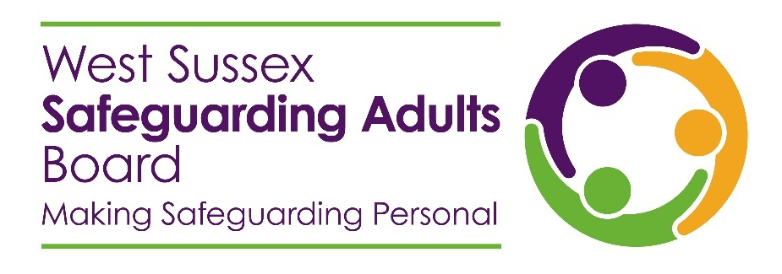
Complex Case - Commonly Held Information Picture (CHIP)

Purpose and use
The aim of the CHIP is to develop a single, informed picture of the person, derived from information from all sources involved in their support. This will enable a single and agreed view of risks, mitigations and actions to be produced, updated and shared with partners and will support multi-disciplinary meetings. This approach has been informed from learning derived from Serious Incident and Rapid Reviews. The CHIP should be regularly reviewed and updated and shared with all agencies involved in supporting the person. They, in turn, should update the CHIP with information pertinent to their involvement and re-share. This will provide a single view of the person and enable appropriate case management.
This document can be used to support multi-agency meetings for complex cases, providing a single record of actions agreed, progress against those actions, and agreed timeframes.
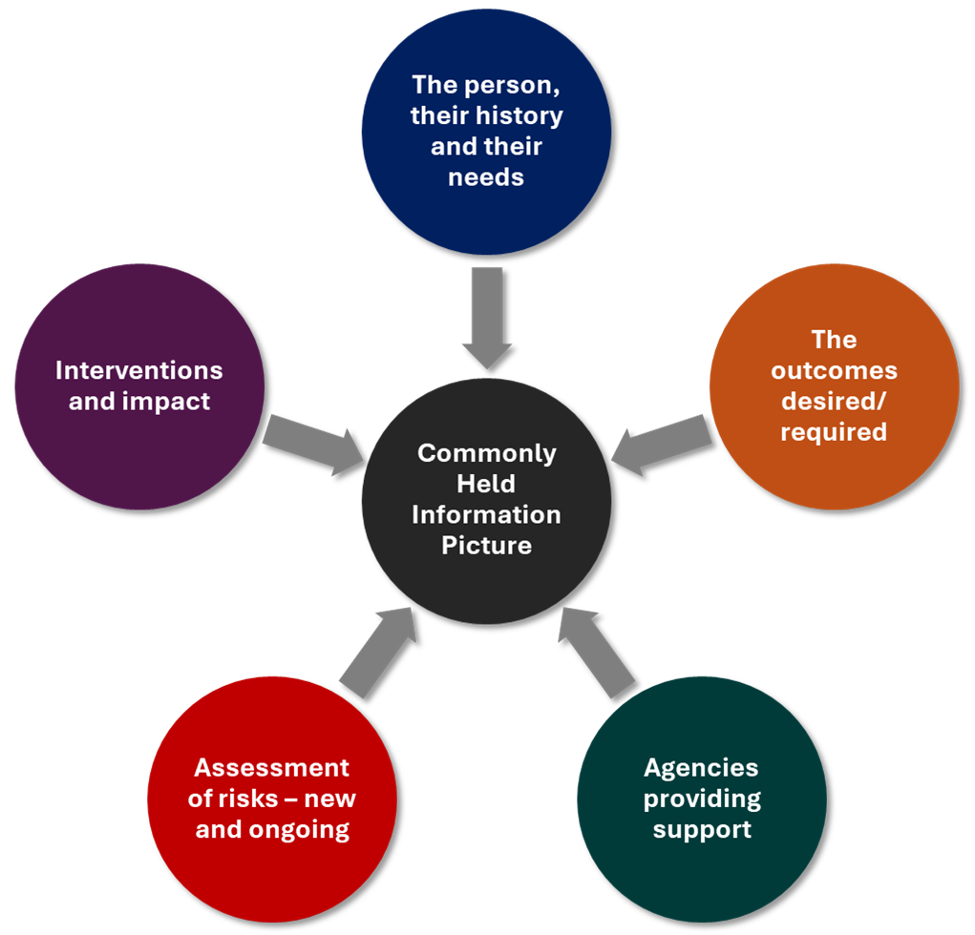
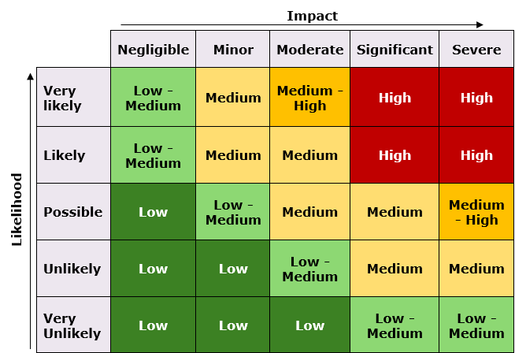
Figure 1: Gathering information for a Commonly Held Information Picture
Figure 2: Risk assessment matrix

Case record
Person name |  | Physical health conditions | Mental health conditions | Agency involvement
Gender |  | Please list | Please list | Agency name | Role | Lead Officer | Telephone and email
Address |  |  |  |  | Choose an item.
 |  |  |  |  | Choose an item.
 |  |  |  |  | Choose an item.
 |  |  |  |  | Choose an item.
 |  |  |  |  | Choose an item.
 |  |  |  |  | Choose an item.
 |  |  |  |  | Choose an item.
Date of birth |  |  |  |  | Choose an item.
Mosaic ref |  |  |  |  | Choose an item.
Desired
outcomes

Brief summary

Event summary
Free text notes should be concise and capture all key points. Once an update is made the form should be shared with all agencies listed above.

Event/episode | Event date | Entry made by (agency) | Comments | Complete if risk entry (see matrix) |  |  | Risk mitigation | Next action | Action status | Date completed
 |  |  |  | Likelihood | Impact | Overall risk
Choose an item. |  |  |  | Choose an item. | Choose an item. | Choose an item. |  |  | Choose an item.
Choose an item. |  |  |  | Choose an item. | Choose an item. | Choose an item. |  |  | Choose an item.
Choose an item. |  |  |  | Choose an item. | Choose an item. | Choose an item. |  |  | Choose an item.
Choose an item. |  |  |  | Choose an item. | Choose an item. | Choose an item. |  |  | Choose an item.
Choose an item. |  |  |  | Choose an item. | Choose an item. | Choose an item. |  |  | Choose an item.
Choose an item. |  |  |  | Choose an item. | Choose an item. | Choose an item. |  |  | Choose an item.
Choose an item. |  |  |  | Choose an item. | Choose an item. | Choose an item. |  |  | Choose an item.
Choose an item. |  |  |  | Choose an item. | Choose an item. | Choose an item. |  |  | Choose an item.
Choose an item. |  |  |  | Choose an item. | Choose an item. | Choose an item. |  |  | Choose an item.
Choose an item. |  |  |  | Choose an item. | Choose an item. | Choose an item. |  |  | Choose an item.

