Safeguarding Adults Review Adult F

Key Themes

This handout is intended to reflect on the key themes identified from the Adult F Safeguarding Adult Review (SAR). A full copy of the SAR can be found here.

Think about what these key themes mean for your practice. Ask yourself?

- Can I make changes to my own practice?
- Do I need to seek further support or training to implement this?

Adult F

In 2017 West Sussex Safeguarding Adults Board undertook a Safeguarding Adults Review, after Adult F, was taken to Worthing Hospital Accident and Emergency because of he had threated to commit suicide. Adult F was a man in his early 20s who had a diagnosis of recurrent psychosis and Asperger’s syndrome, he was found in the hospital grounds in cardiac arrest following a fall from the hospital roof.

Key Theme 1: Escalating concerns

The review found:

Even though General Practitioners (GPs) were consistent in seeking information on behalf of Adult F, the review highlighted the importance of escalating concerns about service provision when GP concerns are not addressed.

What we’ve learnt:

When an agency or professional has raised a concern or query about service provision and that concern with that agency has not been addressed, there needs to be an escalation pathway. There should not be a presumption that another professional ‘knows best’ or abandon ‘niggling concerns’ because of the difficulties and complications of multi-agency working.

Reflecting on practice:

- What do you do to escalate concerns in other’s services on behalf of a person?

- What are the barriers to escalating concerns in your partner agencies?

- If you are faced with barriers to escalating concerns, are their alternative routes to escalation?

Key Theme 2: Carers as active partners

The review found:

When engaging with people with support and care needs, services need to develop a better way to engage with family carers so that carers’ needs and role are central to the planning process.

What we’ve learnt:

In order to have a holistic person-centred approach it is important to consider and record information about the individual’s care needs, potential carer participation and the impact of family history. The ‘Triangle of Care’ model can be an effective way to engage carers.

The disconnected model of involvement below can lead to carers being excluded and failures to share information that may be vital to risk assessment, care planning and to acting in the best interests of both service user and carer.

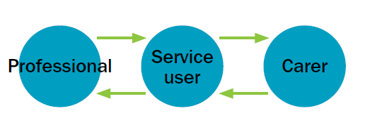

This three-way partnership between service user, carer and professionals, with all the voices being heard and influencing care treatment decisions, will produce the best chance of recovery. This places an onus on professionals and services to actively encourage this partnership.

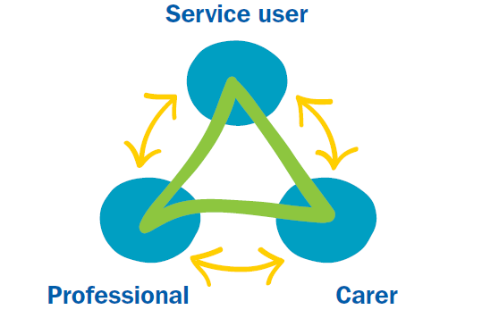

Reflecting on practice:

- Are you and your staff ‘carer aware’ and trained in family and friend carer engagement strategies?

- Have you got clear policies and mechanisms to ensure proactive engagement with family and friend carers?

- Is there a family and friend carer introduction to the service? An introduction could include: an introductory letter; appointment with a named member of the team; orientation, leaflet, carer information packs and discharge planning and aftercare.

You can find a self-assessment tool for carer engagement in Appendix 1 of Carer Trust’s Triangle of Care Best practice guide.

Key Theme 3: Information sharing in transition

The review found:

It is important to share information, to ensure continuity of care, when moving a person from hospital to the community; out of area or with a private sector provider.

What we’ve learnt:

When people are being moved between services, providers or out of area, it is important to develop protocols to ensure continuity of care. Developing protocols and timely sharing of information, co-ordination of care and ongoing relationships can increase positive outcomes, such as continuity of relationships, care, trust and support.

Guidance:

The Social Care Institute for Excellence (SCIE) has produced an Adult Safeguarding: Sharing Information guide which is intended to support good practice around sharing safeguarding information.

Reflecting on practice:

- How do you share information about the person that is in your care who is being moved to another service, locality or provider?

- What practical barriers to information sharing do you face (for example different and incompatible IT systems/paperwork and different policies and procedures); how can you manage or work around these barriers?

- Are you aware that there is specific government guidance, around continuity of care for local authorities when moving between areas? Factsheet 9 of the Care Act 2014 which can be found on GOV.UK.

Key Theme 4: Cultural competence

The review found:

There was an absence of cultural recognition and sensitivity shown to Adult F and his family. It is important to foster engagement that is respectful and culturally sensitive. Training was suggested as a way forward to further cultural competence.

What we’ve learnt:

Cultural competence is being respectful of and responsive to the beliefs, practices, cultural and linguistic needs of diverse communities. The Community Partnership Project Report (London Board, 2007) said there were five essential elements that contribute to an individual professional’s and a whole service’s ability to become more culturally competent. The professional or service must:

- value diversity;
- have the capacity for cultural self-assessment;
- be conscious of the ‘dynamics’ inherent when cultures interact;
- institutionalise cultural knowledge and
- develop adaptations to service delivery reflecting an understanding of diversity between and within cultures.

Reflecting on practice:

- How accessible is your service and information you provide?

- What strategies have you developed to identify cultural barriers to accessing your services?

- Can you demonstrate behaviours, attitudes, policies and structures that enable you to work cross culturally?

Key Theme 5: Developing a culture of questioning

The review found:

It is important to encourage professional curiosity within training and supervision so alternative interpretations can be considered for how a person is presenting, to ensure their assessments are comprehensive.

What we’ve learnt:

It is important for practitioners and professionals to question information they receive and be able to question and balance a person’s autonomy with a duty of care. This also means being able to show both a professional curiosity whilst developing and maintaining relationships. Likewise, is important to consider families in a way that is person-centred. In cases of self-neglect it may mean respectful questioning of a person’s choices and risks whilst being respectful of an individual’s wishes and feelings.

Reflecting on practice:

- How do you deal with ‘unsubstantiated’ concerns, retracted allegations or inconclusive medical evidence?

- What tools help you reduce uncertainty?
For example Sussex Police call handlers in their initial questioning consider the Threat Harm, Risk, Investigation, Vulnerability and Engagement (THRIVE) assessment.

- Are policies, procedures and training in place to enable and support staff to exercise their professional curiosity?

- How can you promote professional curiosity in supervision?

Which Lord Laming in the Climbe report called ‘respectful uncertainty’ (2003) or ‘concerned curiosity’ (Braye, Orr and Preston-Shoot 2015).

