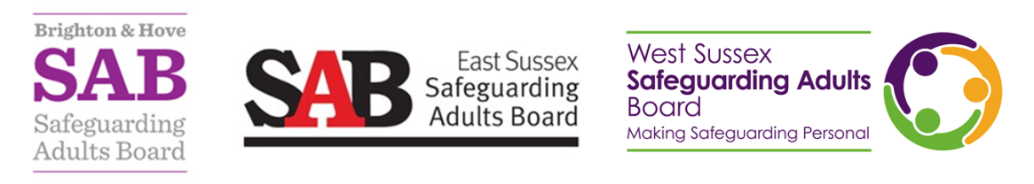

Referring for a Safeguarding Adults Review

This briefing has been produced to support referrers to understand what a Safeguarding Adults Review (SAR) is, and whether a referral is appropriate. Safeguarding Adults Boards (SABs) have a statutory responsibility to consider arranging a SAR when there is concern that partner agencies could have worked together more effectively to protect an adult with care and support needs if they:

- die as a result of abuse or neglect, whether known or suspected;
- experience serious harm;
- take their own life.

The purpose of a SAR is to promote agencies’ learning and improve practice, with the intention of reducing the risk of reoccurrence of the safeguarding incident.

The objectives of SARs include establishing:

- lessons that can be learnt from how professionals and their agencies work together;
- how effective the safeguarding procedures are;
- learning and good practice issues;
- how to improve local inter-agency practice;
- service improvement or development needs for agencies.

The purpose of a SAR is not to:

- be a primary investigation process;
- re-investigate a safeguarding incident;
- apportion blame;
- substitute for a complaints process.

SARs are an important part of safeguarding processes because:

- the findings or recommendations are used to develop action plans for making changes and improvements to services to reduce risks of future harm;
- the learning is shared with SAB partners and other Boards through briefings and events to support continuous development and support good practice.

Making a referral

Your local SAB will consider what type of ‘review’ process could promote effective multi-agency learning and improvement action to prevent future deaths or serious harm occurring to adults with care and support needs.

When considering making a referral please ensure:

- You understand what a SAR is and is not, and consider the criteria:

- If the person is alive, has there been serious abuse/neglect?
- Did or does the person have care and support needs?
- Has there been a concluded enquiry/investigation by an agency (e.g. Adult Social Care, Police, Health)?
- Is there an indication for multi-agency learning?

- Discuss the appropriateness of a referral with your supervisor/manager/safeguarding lead:

- Consider the criteria above and the information in this briefing paper.
- Look at the referral form to see if you are able to evidence in all sections how the criteria is likely to be met.

- Consider contacting your local SAB Board Support Team:

- Following steps (1) and (2), contact your local Board Support Team to discuss and consider whether a referral is appropriate (i.e. that the criteria is likely to be met). You can find contact details for your local Board Support Team at the end of this briefing.

Following the above 3 stages, if you proceed to completing and submitting a referral, please:

- Complete the SAR referral form:

- Complete as fully and with as much detail as possible;
- Be clear about what investigation:
- has already been concluded (e.g. Serious Incident, Root Cause Analysis, s42 Safeguarding Enquiry, Criminal investigation);
- by which agency (e.g. police/Health, Social Care); and
- what the outcome was.
- Submit the form via email to your local Safeguarding Adults Board.

Once you have submitted a referral

Referrals will be considered in line with the Sussex Safeguarding Adults Review Protocol. The referral will be triaged and reviewed by the SAR subgroup who will consider the criteria and make a recommendation to the SAB’s Independent Chair, who then makes a final decision on whether to commission a SAR. The decision-making process will include consideration of the best way, if appropriate, to involve the person, family or carers in the process. If a referral does not meet the criteria for a SAR, another course of action may be taken, instead.

Questions

- Are you clear of the criteria that means a case may be appropriate for a SAR?
- Do you know what action you need to take if you have a case that may meet the SAR criteria?

For more information on this briefing, contact:

- West Sussex Safeguarding Adults Board: safeguardingadultsboard@westsussex.gov.uk
- East Sussex Safeguarding Adults Board: ESSAB.contact@eastsussex.gov.uk
- Brighton & Hove Safeguarding Adults Board: SAB@brighton-hove.gov.uk

