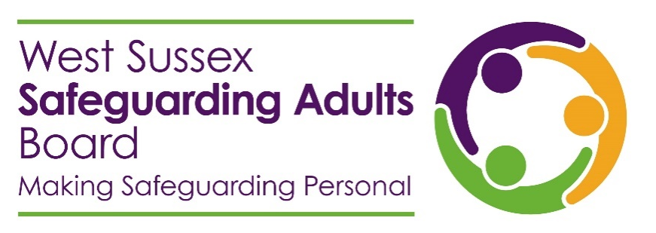

Safeguarding adults practice awards 2024

Introducing the safeguarding adults practice awards
This year, we would like to recognise excellent safeguarding adults practice across the partnership. To do this, we are launching the West Sussex Safeguarding Adults Board safeguarding adults practice awards.
These awards are designed to empower practitioners to recognise and celebrate exemplary safeguarding adults practice. This could be practice by an individual, or by a team. It could be within your own agency, or another agency that you work with.

What are the award categories?
There will be six awards, in line with the six key principles that underpin all adult safeguarding work. When you submit your nomination form, you will be asked to confirm which of the awards you are submitting your nomination for:
- Empowerment
- Prevention
- Proportionality
- Protection
- Partnership
- Accountability

What is the nomination and decision process?
To nominate either a member of staff, or a team, for one of the practice awards, complete the nomination form in this pack. Ensure that you provide information focussing on the impact of the exemplary practice.
Nominations will be reviewed by the statutory partners (West Sussex County Council, Sussex Integrated Care Board, and Sussex Police), who will make the final decision on award winners.

How will the awards be celebrated?
All nominees will receive an acknowledgement of their nomination, in recognition of their practice. These acknowledgements can also be used as evidence for their continual professional development.
Award winners, as well as nominating professionals, will be notified of their success, and invited to the Safeguarding Adults Board Conference. Awards will be presented to award winners at the Conference.

Nomination form

Your details

Your name

Your role

Your organisation

Your email address

Your phone number

Details of the person or team you are nominating

Their name

Their role

Their organisation

Their email address

Their phone number

Award category
Please tick one award category only. For more information about the six key principles of adult safeguarding, visit the Safeguarding adults practice awards page of our website.

Empowerment

Prevention

Proportionality

Protection

Partnership

Accountability

Details of the exemplary safeguarding adults practice

Please provide details of the exemplary safeguarding practice that you have witnessed or experienced.

Describe the impact that this practice has had.

Any other comments.



What happens next?
Submit your nomination to safeguardingadultsboard@westsussex.gov.uk by Friday 16 August 2024.
Nominees will be advised of your nomination.
Winners will be notified in September 2024, and invited to the award ceremony at the Conference on Friday 25 October 2024.

